

**Kovair GitHub**

**Adapter**

**Prerequisites & Installation Guide**

**Kovair Software, Inc.**

2410 Camino Ramon, STE 230  
San Ramon, CA 94583

www.kovair.com

sales@kovair.com

**Kovair Software, Inc.**

2410 Camino Ramon STE 230  
San Ramon, CA 94583

www.kovair.com

|  |  |  |
| --- | --- | --- |
| Document Version History | | |
| Release | **Date** | **Reason** |
| Version 1.0 | 06/21/2016 | Initial release |

Kovair Software is a Silicon Valley based software Product Company specializing in the domain of Integrated Application Lifecycle Management - ALM solutions. Our objective is to make the software development process better, faster and collaborative – anytime, anywhere, using any tool, platform and technology. Kovair’s focus on integrating third party best-of-breed tools enables creation of applications in a synchronized tools environment.

© 2017, Kovair Software, Inc. All Rights Reserved. The Integrated ALM Company.

Table of Contents

Installation Prerequisites 1

Configuring Windows Firewall 1

Unblock Incoming Connections on Windows 7 1

Unblock Incoming Connections on Windows Server 2008/ 2008 R2 2

Installing KovairGitHubAdapter 3

Verifying the Adapter Installation 9

# Installation Prerequisites

The Operating System and other software that must be installed before installing KovairGitHubAdapter are:

* **Operating System**: Windows 2008 Server (for 32-bit machine) / Windows 2008 R2 Server (for 64-bit machine) / Windows 7
* **Internet Information Services (IIS)**: 7.0 or Higher
* **.Net Framework**: 4.0
* **Database Client**: SQL Server 2008 / SQL Server 2008 R2 (Developer, Standard or Enterprise version) / SQL Server 2012
* **Service Packs**: SP 2 for SQL Server 2008 and SP 1 for SQL Server 2008 R2
* **WCF Activation with HTTP Activation**

**Ref:** <http://blogs.msdn.com/b/blambert/archive/2009/02/13/enable-iis.aspx>

## Configuring Windows Firewall

In case Windows Firewall is activated, you need to ensure that it does not block certain incoming connections that are required to install the adapter. The steps given below do not pose any threat to your existing firewall security settings.

### Unblock Incoming Connections on Windows 7

To unblock incoming connections on Windows 7:

1. Open **Control Panel** and change to any other view from "**Category View**".
2. Click **Windows Firewall**.
3. Go to **Advanced Settings**.
4. Click the **Windows Firewall Properties** link that appears at the bottom of the **Overview** section. The **Windows Firewall with Advanced Settings on Local Computer** dialog box appears.
5. Set **Inbound Connections** to ‘Allow’ under all three tabs — **Domain Profile**, **Private Profile**, and **Public Profile**.
6. Click the **Apply** button.
7. Click the **Ok** button.

### Unblock Incoming Connections on Windows Server 2008/ 2008 R2

To unblock incoming connections on Windows Server 2008 and Window Server 2008 R2:

1. Click **Start** 🡪 **Administrative Tools** 🡪 **Windows Firewall with Advanced Security**. The **Windows Firewall with Advanced Security** window appears.
2. Click the **Windows Firewall Properties** link that appears at the bottom of the **Overview** section. The **Windows Firewall with Advanced Settings on Local Computer** dialog box appears.
3. Set **Inbound Connections** to ‘**Allow**’ under all three tabs — **Domain Profile**, **Private Profile**, and **Public Profile**.
4. Click the **Apply** button.
5. Click the **Ok** button.

**Note**: IIS normally handles the firewall configuration on its own during its installation. Opening the required incoming connections are specific to Kovair, and will not affect the existing firewall security settings.

# Installing KovairGitHubAdapter

To install KovairGitHubAdapter:

1. Click the “**KovairGitHubAdapter.exe**” file contained in the **KovairGitHubAdapter** folder.

OR,

If you are installing the adapter on a system for which you are not the administrator, then do the following to execute the “**KovairGitHubAdapter.exe**” file:

* Right-click the “KovairGitHubAdapter.exe” file and select **Run as Administrator**. The **User Account Control** dialog box appears.
* Click **Allow**.

1. On executing the “KovairGitHubAdapter.exe” file, the Windows Installer prepares to install KovairGitHubAdapter, as shown in the following figure:

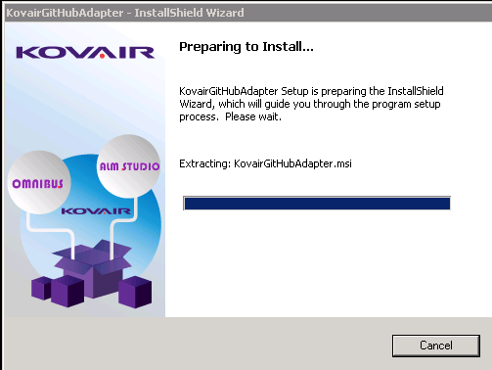

1. After a few seconds, the Welcome page of the **KovairGitHubAdapter Installation Wizard** appears as follows:

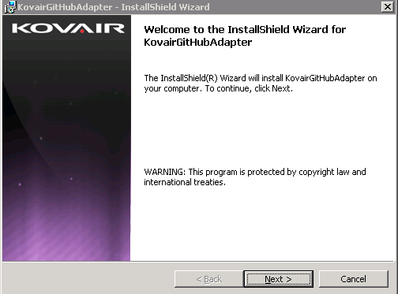

1. Click the **Next** button. The **License Agreement** page appears.

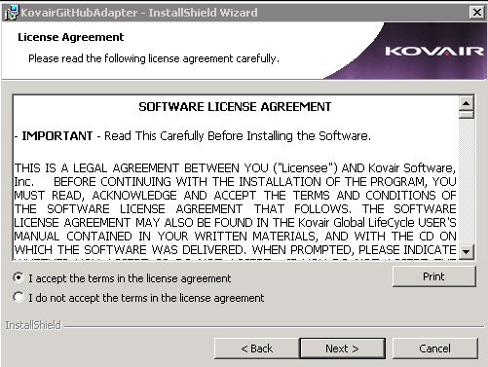

1. Read and accept the agreement and click the **Next** button. The **Destination Folder** page appears, as shown in the following figure:
2. Click the **Next** button to install the adapter at the default location. If you want to install the adapter on some other location, then click the **Change** button and select the location to install KovairGitHubAdapter.

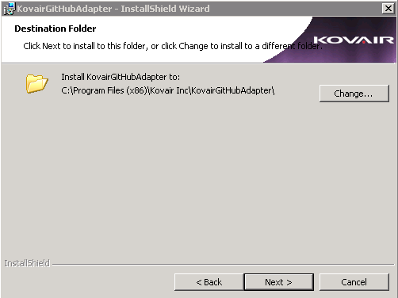

1. On clicking the **Next** button in the **Destination Folder** page, **Application Pool Identity** page appears, as shown in the figure below:

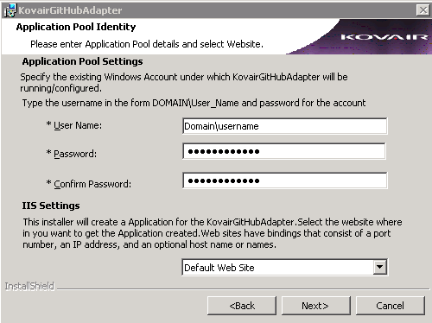

1. Enter the required user name and password that has been added in Administrator group. The installer creates a virtual directory for the adapter.
2. Click **Next.** The **Database Server** page appears as follows:



**Fig**: Database Server Page

1. Click the **Browse** button and select the Database server to be connected to the adapter.
2. Enter appropriate information to connect to your database. You may need to contact your Database Administrator to obtain the required information.

**Note**: The user installing the adapter should have database creator role assigned by the Database Administrator.

1. Click the **Next** button. The **Ready to Install the Program** page appears:

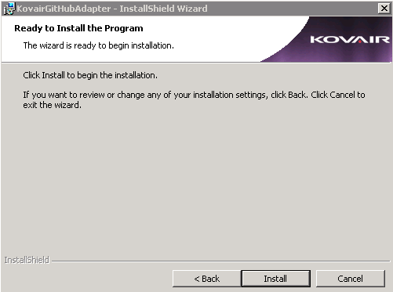

1. Click the **Install** button to begin the installation. The following page appears showing installation in progress:

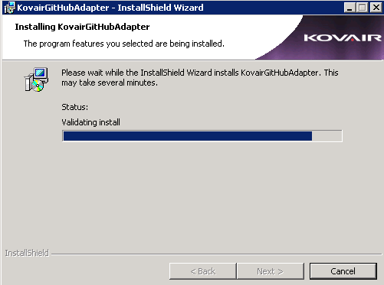

1. After a few seconds, the **InstallShield Wizard Completed** page is displayed.

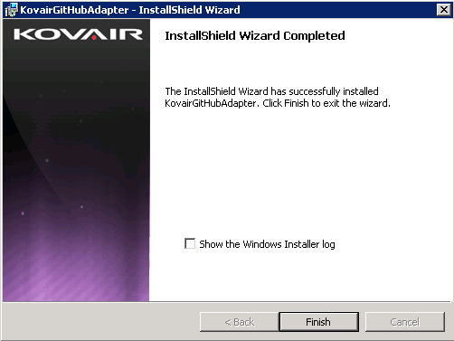

1. Click the **Finish** button. It will open KovairGitHubAdapter URL in a browser.

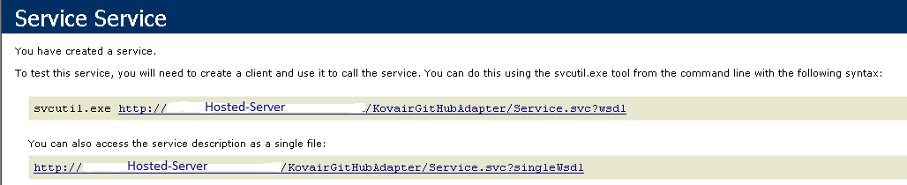

Verifying the Adapter Installation

Click the URL given beside **svcutil.exe** as shown in the figure below and ensure that the page opens without any error.

